Sociosexuality, Attitude and Asymmetry

Hyoeun Oh

Personality lab Psychology 350

Luyao Zhang, Lab section 39822

Nicoletta Wagner

Abstract

This study examines the association between personality trait, in particular, openness, sexual attitude and asymmetry in a sample of 20 University of Illinois undergraduate students. A set of self-report questionnaires was assessed using Big Five personality test for openness and Sociosexual Attitudes (SOI). According to Simpson, Gangestad, Christensen, and Leck (1999), sociosexuality and asymmetry are significantly related. I assume that if someone has body symmetry, then he or she is more likely to be sexually liberal and has more sexual curiosity. When someone is inclined to be sexually unrestricted, I can predict that that person has higher openness in personality than those who have restricted sexual attitude. Finally, I presumed that this study leads to a prediction that people who are physically symmetric have sexually casual attitude. However, the statistical results are so insignificant that it is hard to conclude that facial asymmetry, we measured, is a predictor of sociosexuality. Still, current study makes a specific distinction in attitudes between genders. Further research needs to have a deeper understanding about any confounding variables, and partial correlations such as differentiating gender attitudes, ethnicity, precision on measurements, and other effective factors.

*Keywords*: sociosexuality, facial asymmetry, openness, personality trait.

Sociosexuality, Attitude and Asymmetry

Introduction

Recently, it is widely known that a person who has a perfect facial symmetry is more attractive than one who does not. There have been psychological links on how we perceive other people just by looking at a glance, and it is influenced by physical development as an indirect tactic. Physical attraction is the most apparent but indirect behavioral tactic we can observe. According to Simpson, Gangestad, Christensen, and Leck (1999), symmetrical men were more likely to use direct and bold approaches than asymmetrical men were because more symmetrical men claim they are superior.

Social attitudes, such as being kind to attractive looking person, are natural phenomena based on mating selection by Darwin’s evolutionary theory. But still, can we predict one’s social attitude through physical asymmetry? Some research in evolutionary personality psychology has been raising a question that sexuality, one of social attitude, is predictable from body asymmetry. The individual differences in these social attitudes, together with personality, make up sociosexuality, which is adopted from diverse aspects of social behaviors. I assume that sexual attitude, as one of social behaviors, is associated with personality and body symmetry.

Openness is a personality trait seeking for new experiences, and someone who is higher in open to new experience is insightful, creative and intelligent. According to Eysenck (1972, 1976) and Costa and McCrae (1992), openness to experience would be significantly associated with low levels of sexual guilt and sexual nervousness, which are considered sexual attitudes. It is already found that openness was a significant predictor of low sexual nervousness among males (Heaven et al., 2000). It means that males who are highly open to new experiences do not easily become agitated or tense about sexual activities. Also, more findings from Fernández and Castro (2003) prove that openness has a significant link with sexual attitudes. Due to the openness characteristics, curiosity and willingness to experiment, the unrestricted attitude towards sexuality can be presumed from one’s symmetry. Unrestricted sexual attitude implies that they do not mind engaging in uncommitted romantic relationships or are carefree about sexual activities. It is certain that openness has a significant role in individual’s sexual practices and attitudes. To be specific, Simpson, Gangestad, Christensen, and Leck (1999) emphasize that unrestricted and restricted men act differently on interpersonal sexual attitudes, which are developed from different individual personality attributes. Moreover, they found that sexually unrestricted men are likely to have more symmetry than restricted men. Essentially, the research explains about negative association between sociosexuality and fluctuating asymmetry.

This study contributes to the work in this area by both replicating some of the existing research as well as extending its scope. Like many studies currently connecting asymmetry to attitudes, I try to find a correlation between asymmetry and sociosexuality. By focusing on openness, I extend the research to a less-studied attitude. I combine evolutionary theory with differentiating sociosexuality among the participants. Moreover, I assumed that males have higher unrestrictive sexual attitude than females.

In this research, I aim to explore any association between sexual attitude, openness, and fluctuating asymmetry. Based on my observation, facial symmetry develops a positive correlation with unrestrictive sexual attitude, especially for males. Indeed, facial asymmetry predicts the unconventional characteristics of being unrestrictive.

Method

Nicoletta and I recruited subjects to find out their sexual attitude, openness, and facial asymmetry. The samples were 10 male and 10 female undergraduate students in University of Illinois at Urbana-Champaign. They consented to participate without any compensation. 9 out of 20 samples were currently in a romantic relationship. Ethnicity of samples was diversely collected but a majority, 50 percent, of the subjects was Asian. Subjects had a self-report questionnaire that has 20 sexual attitude (Sociosexual Attitudes), 10 openness (Big Five personality test), and 4 demographic questions (one question for subject ID). Each item is rated on how much you agree that statement on a 5-point Likert scale: “Strongly agree (1), Agree (2), Neutral (3), Disagree (4), Strongly Disagree (5)”. Four demographic questions were categorical about gender, status of a romantic relationship, ethnicity and marital status of parents.

I took a picture of each participant’s face so that one’s whole facial outline fits in a full screen of the smart phone. We had a simple guideline for every photograph. Stand against white or bright wall, do not smile but please make a serious face, look straight into the camera, and do not tilt your head. I cropped the top of chins touching the picture’s horizontally, and resized the horizontal size to 350 pixels and vertical to auto. To quantify asymmetry, we marked three central points on the face. I separated the left and right sides of the face in center at the tip of nose (a). As described in Figure 1, I measured the distances from the tip of the nose (a) to the end of white pupil on left eye (b1), from the tip of the nose (a) to the tip of the lip (c1), and from the white pupil (b1) to the tip of the lip (c1). The distance from three measurements was measured in centimeters, and the absolute difference between left and right side provides the index of asymmetry. After getting squared differences between left and right facial measurements, average of these three measurements was used to get a composite score of asymmetry.

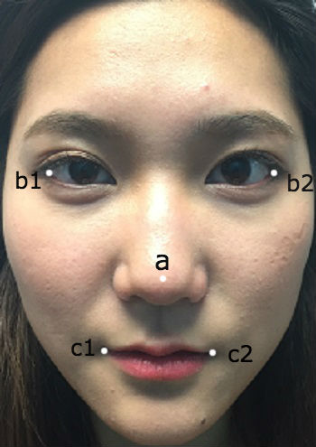 Figure 1.

Results

After Nicoletta and I collected our data about all 20 subjects, I analyzed each variable’s statistical results. Over all the samples, 10 questions of unrestricted sexual attitude such as “Sex without love is ok” is rated on neutral as *mean* = 3.16 (*SD* = 1.14). Restricted sexual attitude derived from 10 questions such as “I can easily see myself engaging in a long-term romantic relationship with someone” is rated on agree as *mean* = 1.57 (*SD* = 0.50). The variability from restricted sexual attitude was more consistent than unrestricted one. See Table 1 for means and standard deviation of sexual attitude, openness, and facial symmetry.

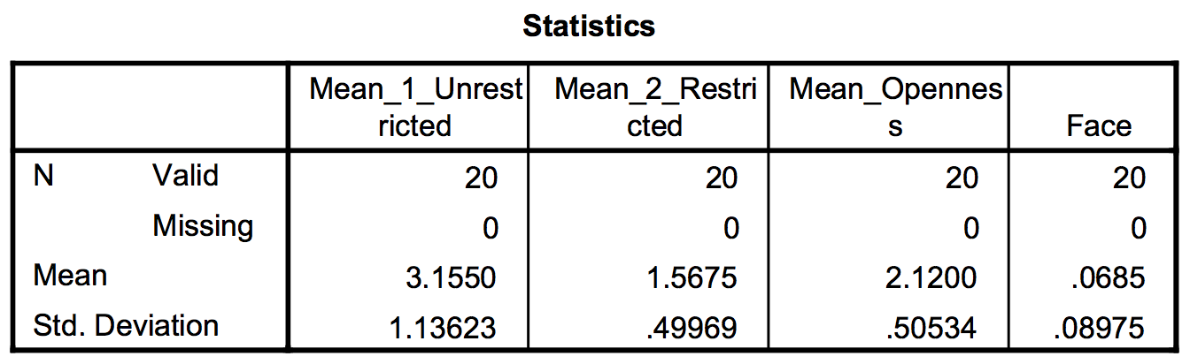

Table 1. Statistical results of all four variables

The correlation between unrestricted sexual attitude and openness is -.18, and the correlation between restricted and openness is .20. Both correlations are small indicated as insignificant. Theses results were unexpected and actually opposite to my expectation. What I assumed is that unrestricted sexual attitude is positively correlated with openness since its openness to new experience attitude leads with more curiosity and unconventional personality. Our finding is that each correlation between facial symmetry and sociosexuality is -.04 (unrestricted) and -.08 (restricted). We were very surprised by the results since the correlation outcomes are insignificant even below 0.1, which mean there is no association between two variables.

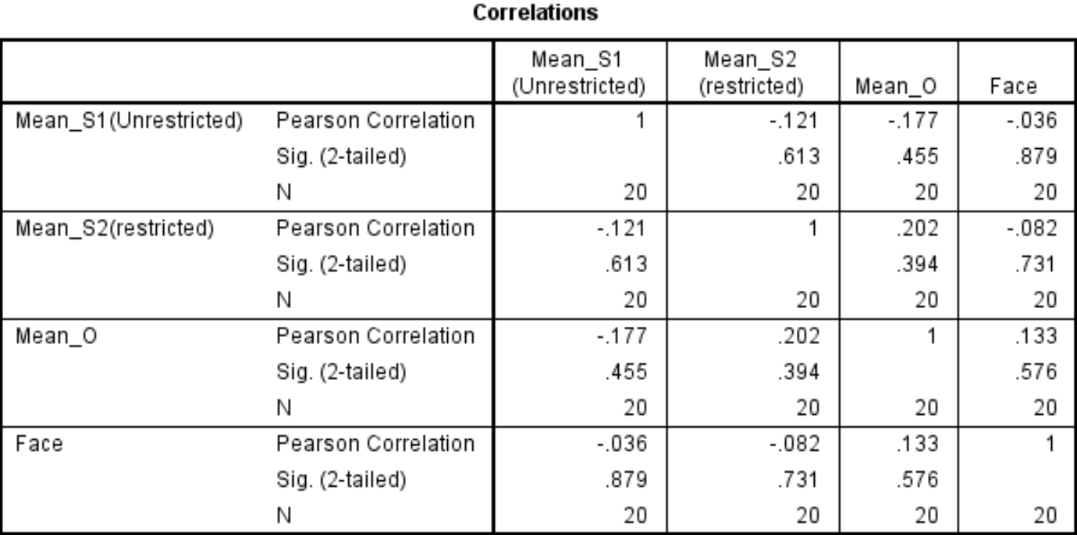

Table 2. Correlations for four variables

Due to unexpected outcomes, I had to do some more analysis with gender. The statistical result shows that unrestrictive sexual attitude of females, *mean* = 3.73 (*SD* = 1.30), higher than that of males, *mean*= 2.68 (*SD* = 0.75). This is important to note because the sample means of gender shows deviating from what I assumed that males have higher unrestrictive sexual attitude. I guess other variables such as cultural difference and social context might have caused different outcomes. I found a significant result that unrestrictive sexual attitude and openness is -.41 among males. It indicates a small correlation between two variables. Another finding from gender analysis is that the correlation between restrictive sexual attitude and openness among females is 0.49. But still, the relationship of facial symmetry effect on unrestrictive sexual attitude among males is -.06.

Discussion

Few research have been studied about personality trait and sociosexuality. But still, there are findings that imply the association between openness to new experience and sexual attitude. In fact, it is studied that certain sexual attitude can be predicted from one’s fluctuating asymmetry (Simpson, Gangestad, Christensen & Leck, 1999). The current research seeks the relationship how the symmetrical measures becomes a predictor of unconventional sexual attitude, based on a specific personality trait.

I assumed that unrestrictive sexual attitude is associated with openness to new experience and physical symmetry. However, our research finding uncovers non-significant results between sociosexuality and facial symmetry. As a result, our hypothesis fails to predict the symmetry associated with sociosexuality. To understand the insignificant results, we consider some limitations on the current study. The sample size was too small to generalize the population’s sociosexual attitude, and asymmetry. Sampling variability can cause low sample correlations at the end. Also, measuring facial asymmetry could be imperfect in getting the precise size. From Costa and McCrae (1992), it is noted that personality attribute, especially openness, affects indirectly sociosexuality. Our major research question that remains unanswered whether asymmetry actually can predict one’s sexual attitude, and further his or her personality. Most importantly, further research needs more understanding about any confounding variables, and partial correlations such as differentiating gender attitudes, ethnicity, precision on measurements, and other effective factors.

Reference

Costa, P. T., Jr., & McCrae, R. R., (1992). The revised NEO personality inventory (NEO-PIR)

and NEO five-factor inventory (NEO-FFI) professional manual. Odessa, FL:

Psychological Assessment Resources.

Eysenck, H. J. (1972). Psychology is about people. Harmondsworth: Penguin.

Eysenck, H. J. (1976). *Sex and personality*. London: Open Books.

Heaven, P. C., Fitzpatrick, J., Craig, F. L., Kelly, P., & Sebar, G. (2000). Five personality factors

and sex: Preliminary findings. *Personality and Individual Differences*, *28*(6), 1133-1141.

Fernandez, M. L., & Castro, Y. R. (2003). The Big Five and sexual attitudes in Spanish

students. *Social Behavior and Personality: an international journal*,*31*(4), 357-362.

Reise, S. P., Wright, T. M. (1995). Personality traits, personality disorders, and sociosexuality.

Journal of Research in Personality, 30, 128–136.

Simpson, J. A., Gangestad, S. W., Christensen, P. N., & Leck, K. (1999). Fluctuating asymmetry,

sociosexuality, and intrasexual competitive tactics.*Journal of personality and social*

*psychology*, *76*(1), 159.

Wright, T. M., & Reise, S. P. (1997). Personality and unrestricted sexual behavior: Correlations

of sociosexuality in Caucasian and Asian college students. *Journal of Research in*

*Personality*, *31*(2), 166-192.